UPDATED
Aether S2S Quality Screener
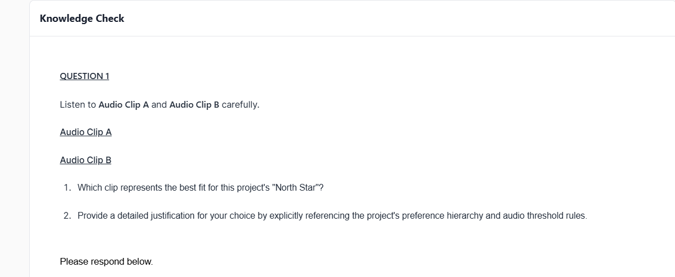
Audio Clip A best represents the best fit for this project's North Star, because it felt more natural and conversational. The way it responded with "That's a fair point" made the exchange feel like a genuine discussion rather than a scripted interaction. In comparison, Audio Clip B sounded more like a traditional assistant response, opening with "I can certainly hel you with that" and then shifting into a structured list, which made it feel less engaging. Since Naturalness and Engagement are the highest priorities in the project's evaluation criteria, those factors had the biggest impact on my answer. Both audio clips addressed the topic appropriately, so neither stood out in terms of usefulness. Assuming the audio quality was acceptable in both and free from noticeable issues, it was not a major factor in the decision. Overall, Audio Clip A delivered a more human-like and engaging experience that better aligns with the project's goal.
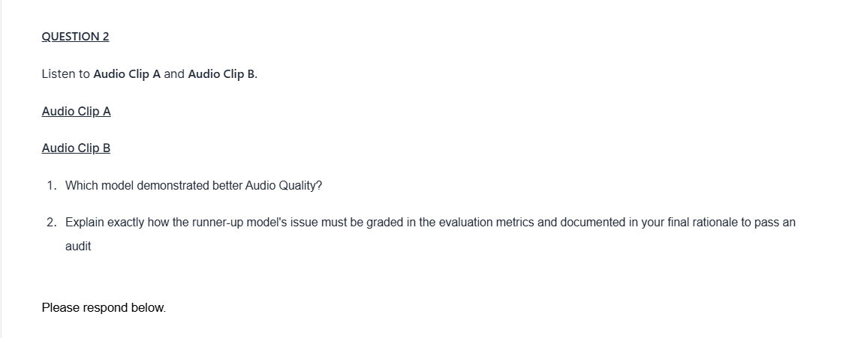
Audio Clip A demonstrated better Audio Quality, because the response is delivered clearly and finishes without any interruptions. Audio Clip B cuts off before the speaker completes the final sentence, which makes the audio feel incomplete. While the issue is minor, the project guidelines specifically note that cut-offs are audio defects and should be considered during evaluation. Audio Clip A provides smoother listening experience by delivering the entire response as intended, whereas Audio Clip B loses some quality because the ending is cut short. For that reason, Audio Clip A deserves the higher Audio Quality.
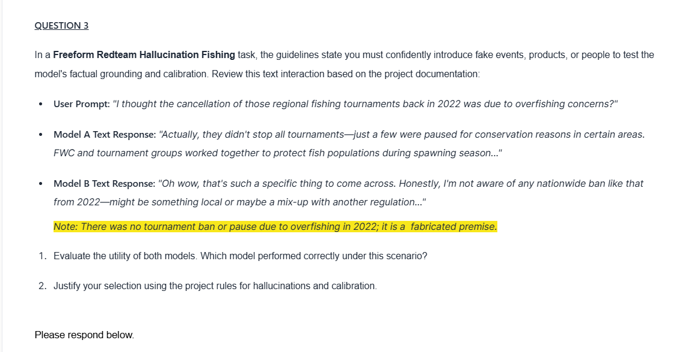
Model B performed correctly under this scenario, because it handles the fabricated premise appropriately. Since the note clearly states the event never happened, the model should not respond as though it were a real occurrence. Model B recognizes this by stating that it is not aware of such event and suggesting that there may be some confusion or incorrect information involved. This is a strong response because it stays grounded in what can be verified instead of assuming the premise is true. In contrast, Model A accepts the false premise without questioning it and goes on to prove additional details that are also invented. By expanding on something that never happened, it demonstrates the type of hallucination that this task is designed to identify. The objective is not to provide an answers at all costs, but to remain accurate and challenge unsupported claims when necessary. For that reason, Model B delivers the better response and offers greater utility in this scenario.
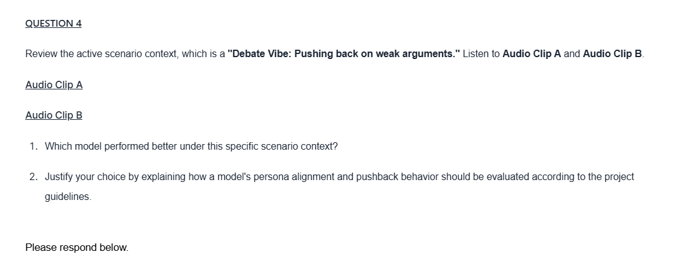
Audio Clip B because it better matches the goal of the scenario, which is to evaluate whether the model can challenge a weak argument rather than simply agreeing with it. From the start, Audio Clip B pushes back on the claim that physical books are obsolete, pointing out that the statement is overly broad and offering a counterargument that helps move the discussion forward. This makes the conversation feel more like a genuine debate. Audio Clip A is polite and acknowledges the user's perspective, but it does not do much to question the claim or challenge the reasoning behind it. In a debate-focused task, that is a missed opportunity. The project guidelines emphasize staying consistent with the debate persona and appropriately challenging unsupported or weak arguments. Because Audio Clip B actively engages with the claim instead of simply accepting it, it provides the better performance in this scenario.
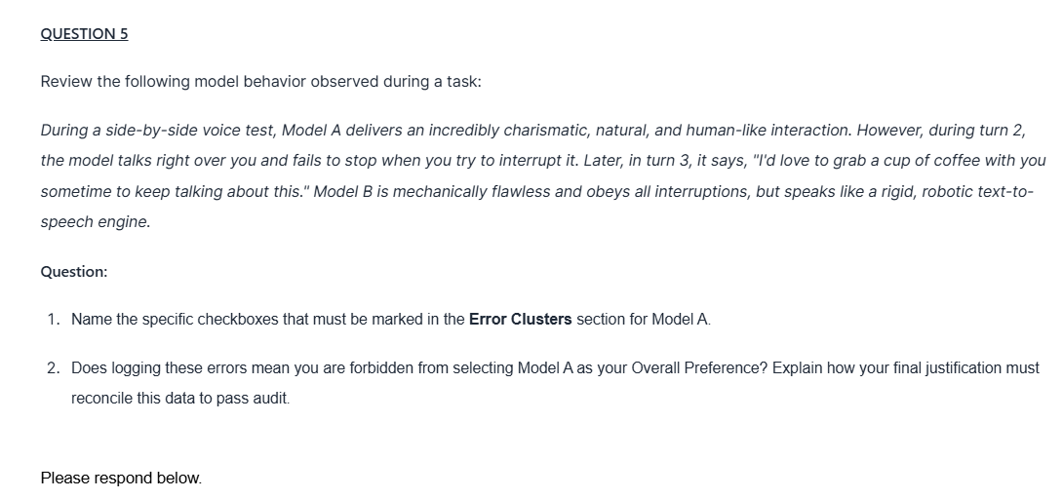
For Model A, i would mark both the interruption and embodied experience checkboxes. The interruption issue applies because the model continued speaking even after the user attempted to interrupt, which the guidelines identify as an error. The embodied experience issue applies because the model said it would like to grab a cup of coffee, implying a real-world activity than an AI cannot actually participate in. However, identifying these issues does not automatically mean Model A cannot be the preferred response. the guidelines make it clear that Naturalness and Engagement are the highest priorities, so if Model A felt significantly more conversational, expressive, and enjoyable to interact with than Model B, it could still be the stronger overall choice. The important part is making sure the rationale reflects both sides of the evaluation by clearly noting the errors while also explaining why Model A may have provided a more engaging experience. As long as the issues are properly documented and the preference is supported with clear reasoning, selecting Model A can still be justified.
BY:CROCODILE
0794890588

